- The problem:
- The sum of four consecutive 3-digit numbers is 866. What are the four numbers?
- (“Math Makes Sense 6”, Pearson, 2006, p. 63)

The Model:
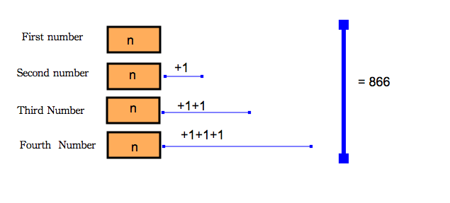

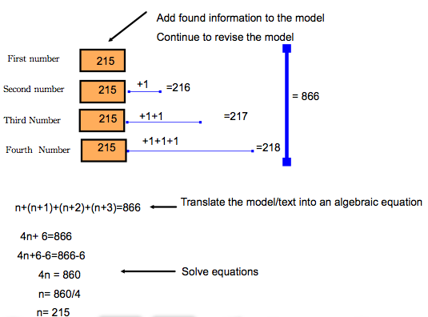
Procedural-symbolic stage

